**Tazhibayev Sultanbay**

**SE-2326**

# **Advanced Databases (NoSQL) | Omirzak Islam**

Assignment 3.1

**Task.1**

Create collection with schema validation rules for some specific fields in data from tv-shows.json file. Then import data from the attached tv-shows.json file into created collection. 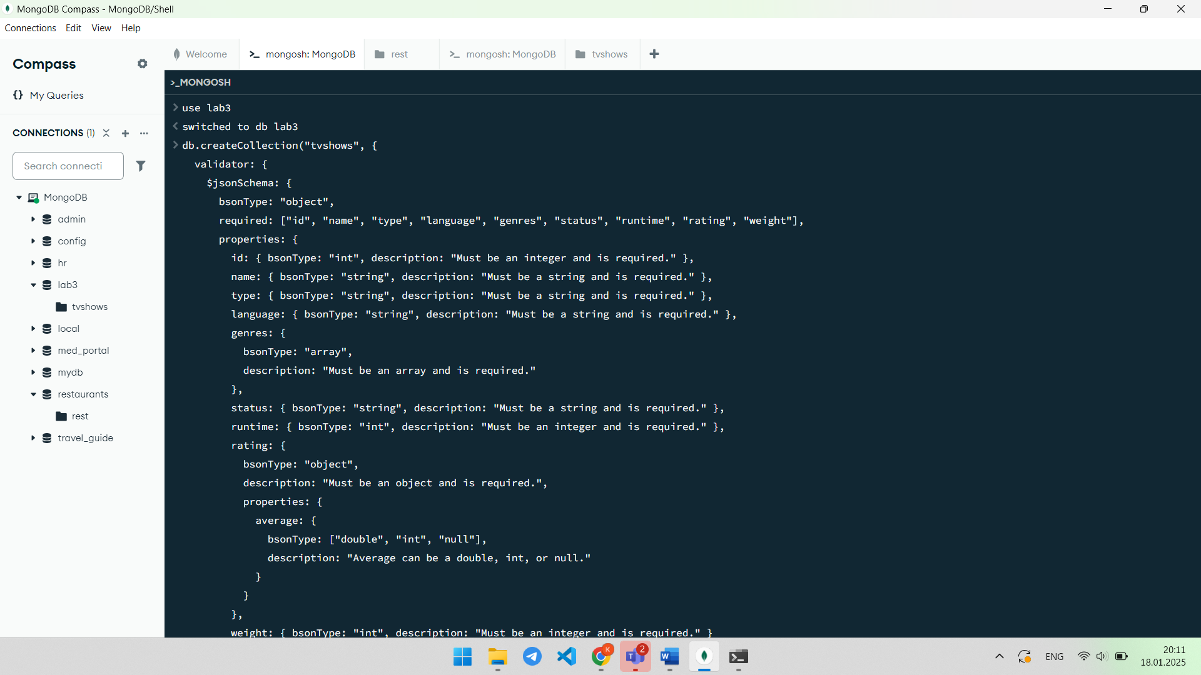

Explanation: In this task, a collection is created with schema validation rules, and data from the tv-shows.json file is imported.

**Task 2**

Using insertMany() method, deliberately insert duplicate _id data to your collection, and “fix” failing additions with unordered inserts.

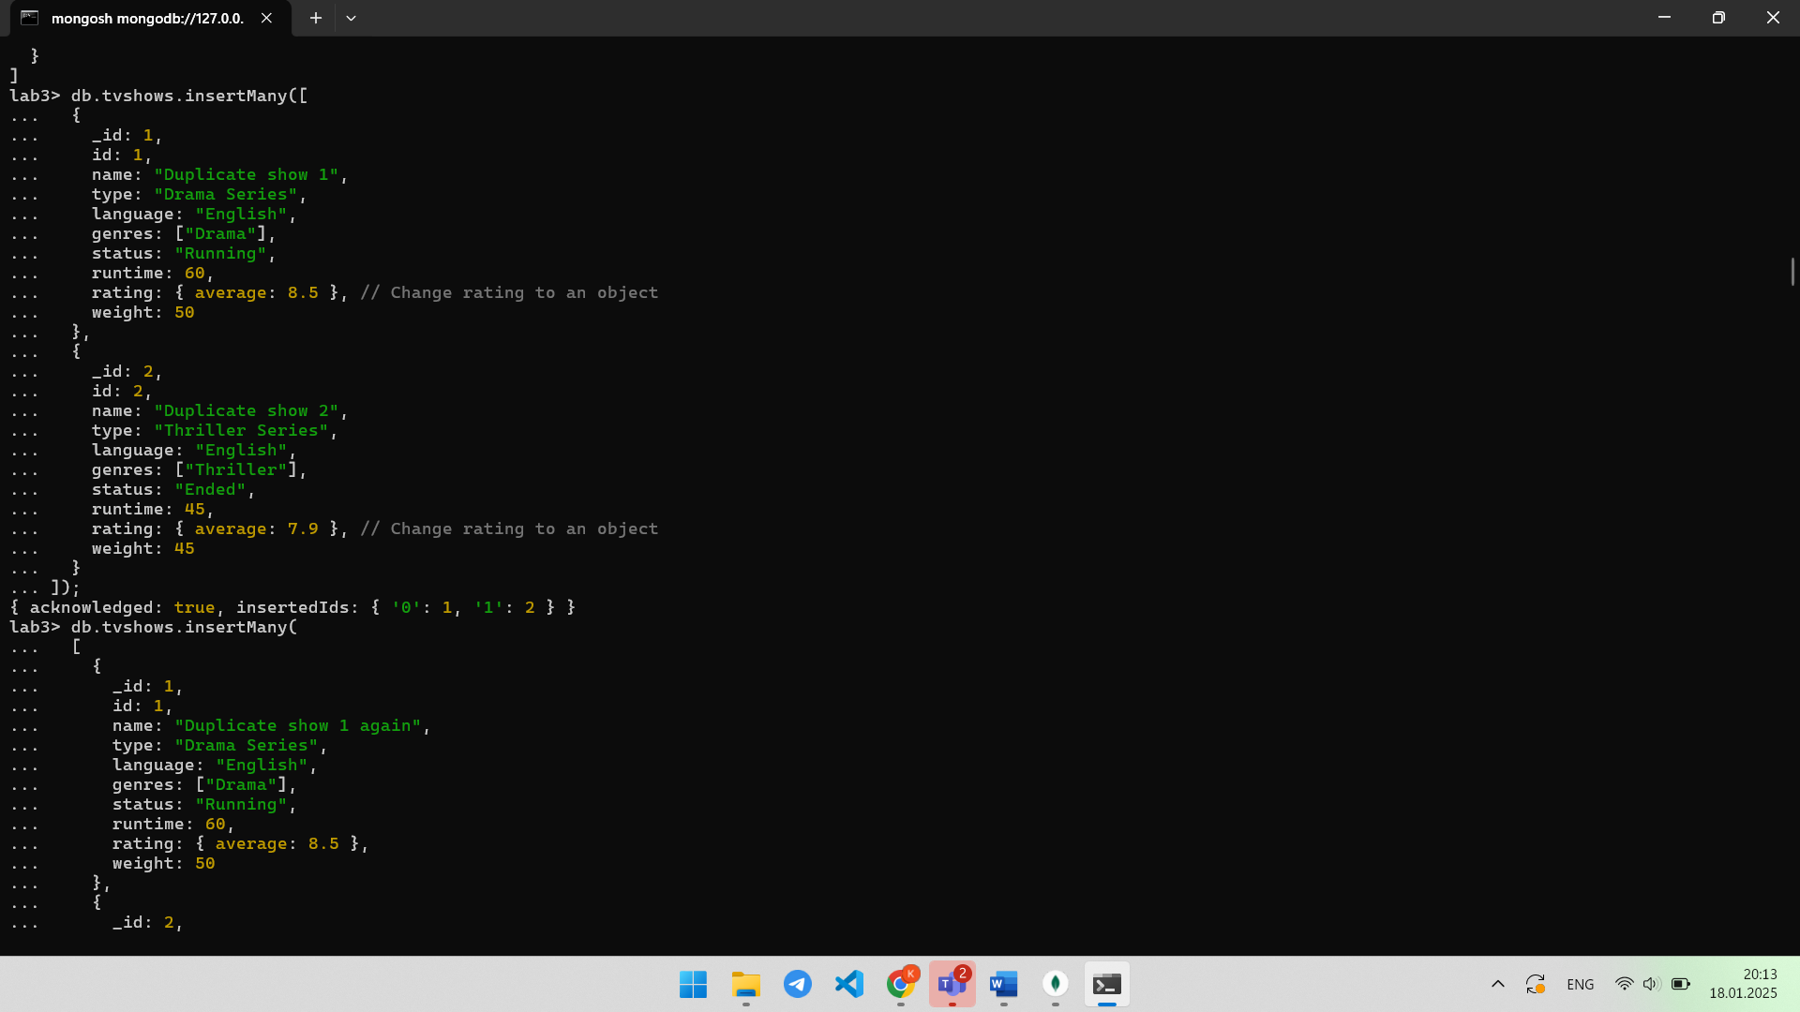

Explanation: The insertMany() method is used to add duplicate data, demonstrating the functionality of ordered and unordered inserts.

**Task 3**

Write data for a new movie with both journaling being guaranteed and not being guaranteed. Explain the difference between specifications.

Explanation: This task shows data recording with and without journaling, explaining the differences between the specifications.

**Task 4**

Search all movies where runtime exceed weight.

Explanation: This task involves searching for movies with a runtime exceeding a specified value.

**Task 5**

Find all movies with exactly two genres.

Explanation: This task is about identifying movies that belong to exactly two genres. The goal is to filter and list movies where the genre classification is limited to just two categories, excluding any films that fall into more or fewer genres.

**Task 6**

Find all movies where genres contain Comedy and Science-Fiction independent of order

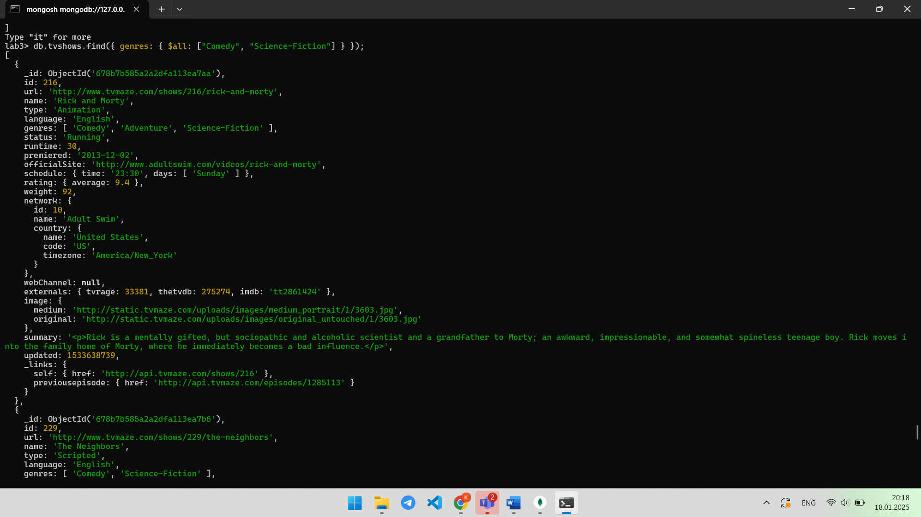

Explanation: The task is to search for movies whose genres include both Comedy and Science Fiction, regardless of the order. The goal is to find movies that fall under these two specific genres, without considering their sequence in the genre list.

**Task 7**

Find all movies with next episode link and where data type for average rating is 32-bit int (use BSON Type ID).

Explanation: The task is to search for movies that have a link to the next episode and the data type of the average rating as a 32-bit integer. The goal is to filter movies that provide a reference to the upcoming episode and ensure the average rating is stored as a 32-bit integer.

**Task 8**

Using programming\mongodb skills write command to get number of documents after cursor iteration from the default value to 50. Use no less than 3 different ways.

1. **itcount():  
   **
2. **toArray():**



1. **forEach loop:**

Explanation: The task is to use various methods to obtain the number of documents after iterating through a cursor. These methods include `itcount()`, `toArray()`, and the `forEach` loop. The goal is to demonstrate different techniques for counting the documents once the cursor has been iterated.

**Task 9**

Write command to print message “Great movie is ” and movie name, where rating is more than 8 and web channel is not null.

Explanation: The command outputs the message "Great movie is" followed by the movie title if the rating is greater than 8 and the web channel is not null. This condition ensures that only movies with high ratings and valid web channels are considered for displaying the message.

**Task 10**

Write command to get cursor information with its explanation.

Explanation: The command is used to retrieve information about the cursor, providing details such as the current position, the number of documents, and other relevant properties. This helps in understanding the state of the cursor and its behavior during data retrieval.

**Task 11**

Using restaurants db, write 2 example queries, where it's necessary to use the $elemMatch operator.

Explanation: The task is to use the `$elemMatch` operator in MongoDB with two example queries on the "restaurants" database. The `$elemMatch` operator is used to query array fields in documents, ensuring that the query matches elements within the array that meet multiple conditions. Examples will demonstrate how to use `$elemMatch` to filter restaurants based on specific criteria within an array field.

**Task 12**

Using restaurants db, write 2 example queries, where it's necessary to use cursor with toArray() method.

**2)**

Explanation: The task is to provide two example queries using a cursor and the `toArray()` method in the "restaurants" database. The `toArray()` method is used to retrieve all the documents returned by a cursor and store them in an array. These examples will demonstrate how to use a cursor for querying the database and then convert the results into an array for further processing.